

Padlet ‘Copy to Each User’ Option

Although Padlet is normally used as a collaborative tool in group work, it can also be used as a as a scaffolding tool for individual students, structured in the way you wish the students to work. By default such Padlets are seen only by the teacher and the individual student.
The steps below show how to give each of your students a scaffolded Padlet for individual use.

Add the Padlet to Your Moodle Page
Turn editing on and in the required section, click on ‘Add an Activity or Resource’
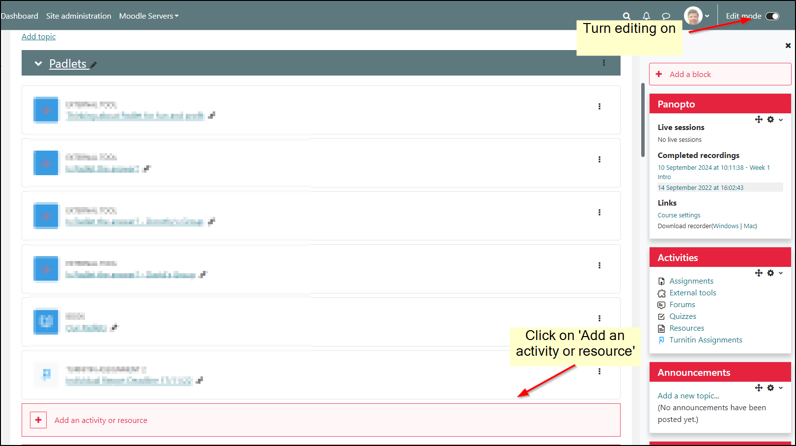

Select ‘Padlet’ from the list of activities.
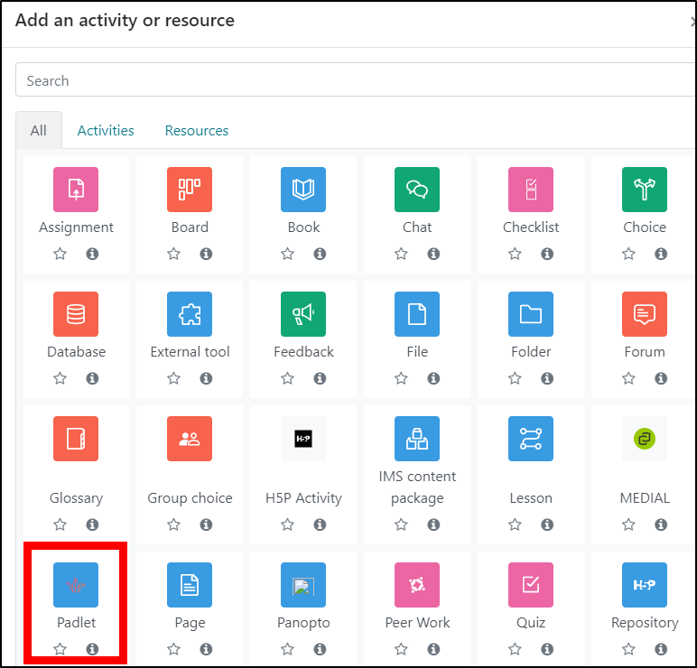
Click on ‘Select Content’.
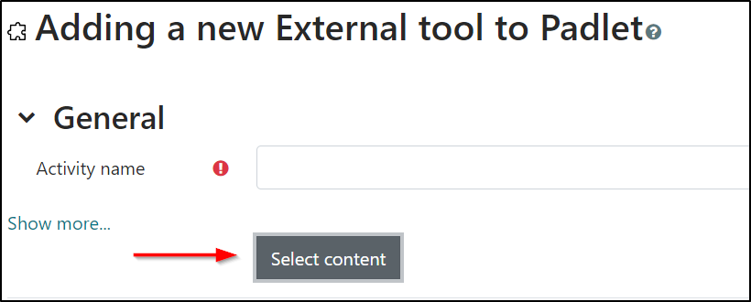

Create the Padlet
You can select an already created Padlet, or create a new one by clicking ‘Make a Padlet’.

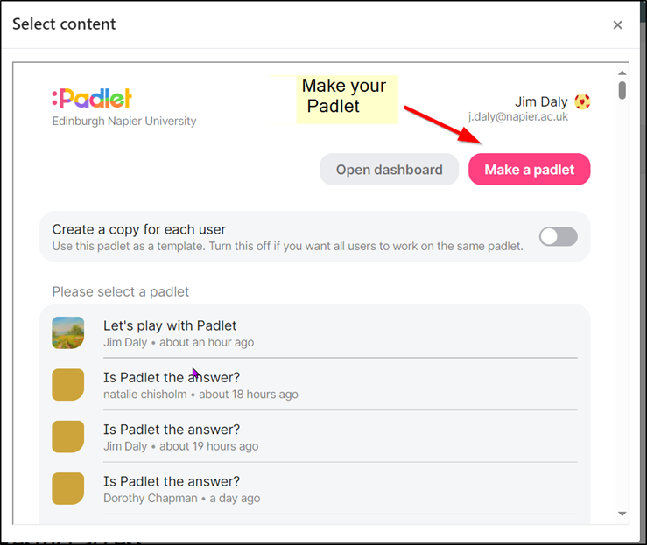
Add guidance posts or sections which make it clear to the student what is required of them. Once done, close the browser tab.
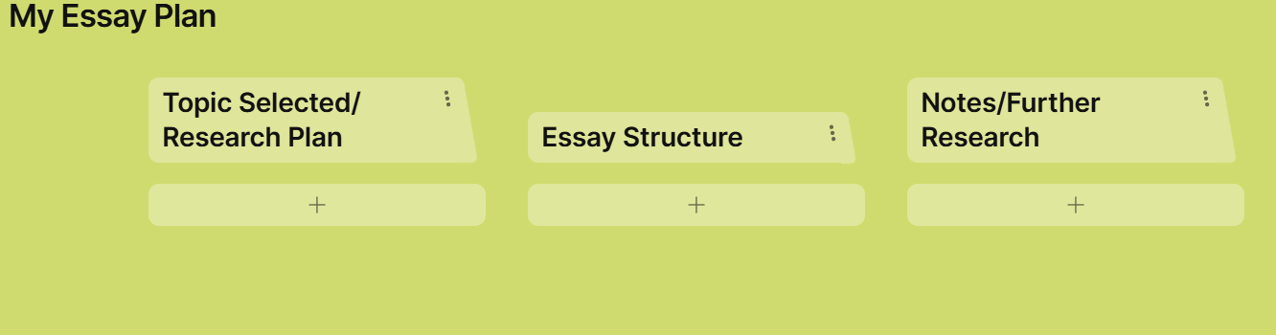

You will need to refresh your view to see a Padlet created after you opened this window. Click on ‘Okay’ and close the window.
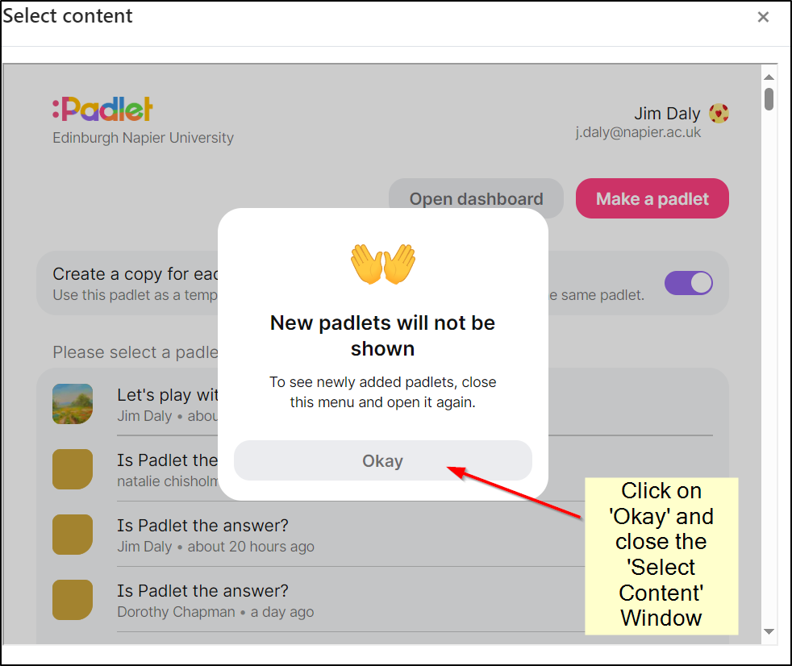

Now click on ‘Select Content again.

Give Students Copies of Your Padlet
You should now be able to see your new Padlet. If you are ready to do so, turn on the ‘Create a Copy for Each User’ and then select the Padlet.
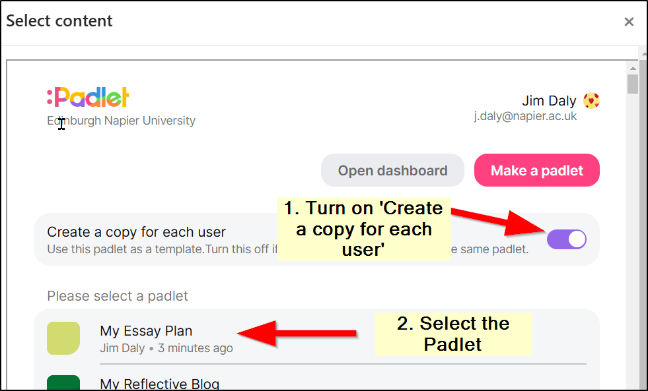

You will find yourself back in Moodle. Click on ‘Save and Return to Course’ or ‘Save and Display’ if you want to view the Padlet.

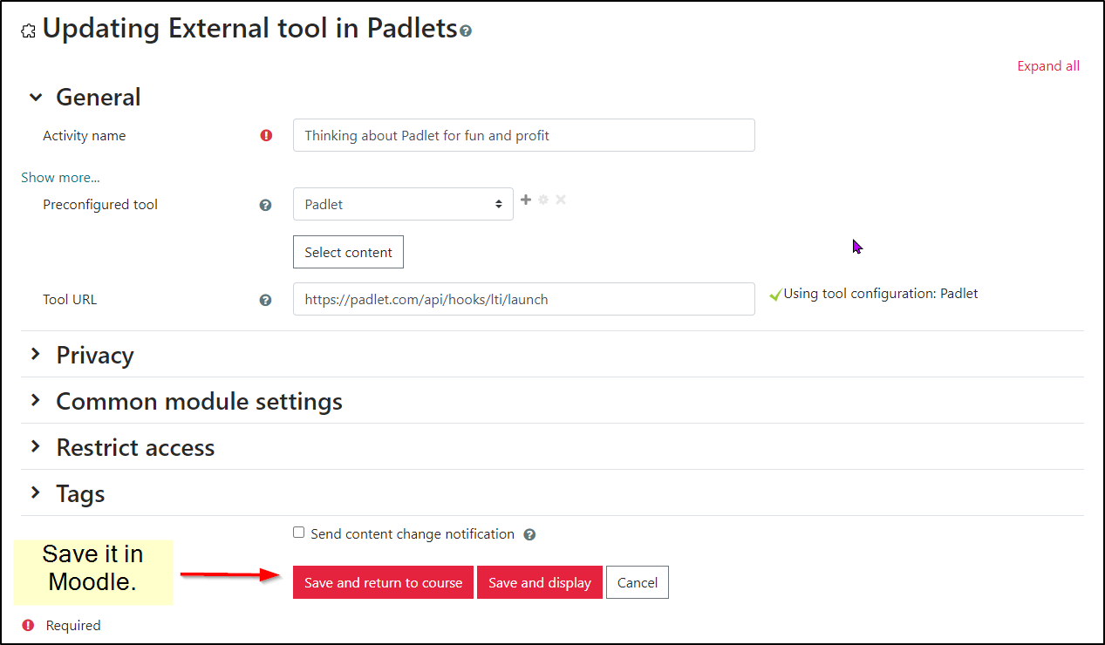

Student Use of the Padlet
When the student clicks on the link you have created in Moodle, they will get their personal copy of the Padlet you have created, which they can now edit.

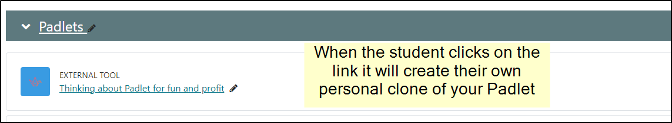

Viewing Student Padlets
You can view student Padlets by clicking on the Moodle link and then clicking on the arrow icon on the top-right of the Padlet. Alternatively, you can view them directly in Padlet at https://edinburghnapier.padlet.org

Student Padlets and Moodle Assignments
If the student Padlets are to be assessed work, create a Moodle Assignment and require the students to upload an exported version to the Moodle Assignment. Moodle Assignments are backed up by the University, ensuring student work is never lost.
Although not an exact visual reproduction of the original, the ‘Export to PDF’ option provides a reliable reproduction of the content of a student’s Padlet

