Write the title of the paper here
Ana Tending-Author¹, Colin L Arborator² and Teresa CD Wood³
1) Timber University of Reykjavik, Iceland, a.tendingauthor@timberuni.is
2) The Industrial Wood Research Centre, United Kingdom, colin.arborator@iwrc.co.uk
3) The Industrial Wood Research Centre, United Kingdom, teresa.wood@iwrc.co.uk

Background
Use this template as the basis for your extended abstract. Write the title of the paper at the top, followed by the author names formatted in the style of the example (first name, initials, surname). Underline the name of the author who will present the paper at the conference. Affiliations should be listed below, indicated by superscript numbers after the author names. The affiliation should contain organisation name, country and email. Save the abstract as a Word (.docx) format or OpenDocument Text (.odt) format. The filename should be the surname of the first author followed by the first few meaningful words of the title (enough to make it recognisable). Please email it to WSE-Edinburgh@outlook.com before 26 August 2024.
A typical paper should follow the standard format used by WSE conferences with sections titled “Background”, “Experimental”, “Results and Discussion”, “Conclusions” and “References”. Different section titles can be used if more appropriate to the subject of the paper. The extended abstract should be no more than 3 pages plus references. A length of 2 pages plus references is the ideal goal. Cite using the name and date style, e.g. Trask (1997), Bodig and Jayne (1982), Larnøy et al. (2021). Format references following the style of the given examples below.
The background section should briefly present the scope and objective of the paper, and state the challenge that motivated this research, briefly review the pertinent literature, and describe the possible use of your research. Try to structure the motivation text by thinking about these questions: 1. What is the background of your topic? 2. Why is the topic important? 3. What has been done already in the field? 4. What knowledge is currently missing? 5. What is my paper offering to fill this gap? 6. Which terms do I need to define? Write one or two sentences to address each question.
Keywords: keyword, keyword, keyword

Experimental
Please provide information about your material and methods, keep it short and refer to standardized tests when you can.

Subheading example
If you need to use subheadings, there should be only one level. The subheading itself is style “Heading 2” (Arial, 12 pt, line spacing before 8 pt and after 4 pt). Headings are style “Heading 1” (Arial 12 pt bold, line spacing before 12 pt and after 4 pt). Use sentence case capitalisation for the headings.

Results and discussion
Here is more example text, including cross-reference to Figure 1 and Table 1. Use metric units and round to an appropriate number of significant figures for the uncertainty of the measurements and calculation results. Tables, figures and captions should be centred on the page.

Table 1: Caption above the table
Text* | Text  [g] | Text  [-] | Text  [%] | Text**  [N/mm²] | Text  [km] | Text
Text | 10.0 | 1 | 10 | - | 400 | Hill (2007)
Text | 10.1 | 2 | 15 | - | 450 | Bodig & Jayne (1982)
Text | 10.3 | 5 | 20 | 16 | 500 | Larnøy et al. (2021)
Text | 15.5 | 6 | 27 | - | 650 | Stamm (1967)
Text | 0.70 | 10 | 87 | 24 | 850 | -
* You can use explanatory footnotes in tables
** More than one explanatory footnote if necessary

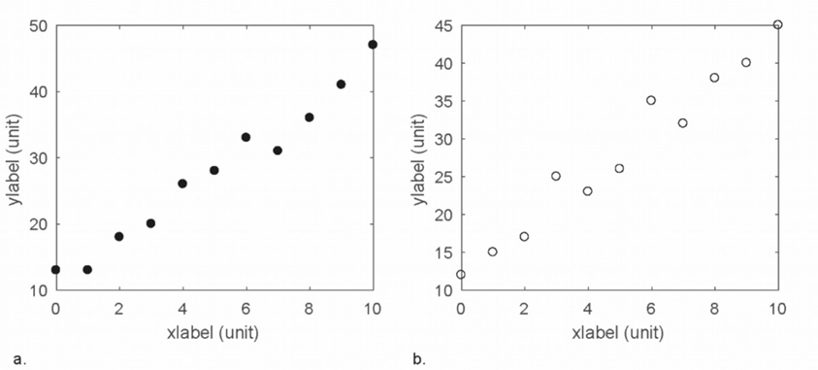
Figure 1: Caption below the figure

Conclusions
Keep your conclusions concise. You can describe any ongoing or future work.

References
Bodig J; Jayne BA (1982) Mechanics of wood and wood composites. Van Nostrand Reinhold, New York.
Hill CAS (2007) Wood Modification: Chemical, Thermal and Other Processes. John Wiley & Sons, Southern Gate, Chichester.
Larnøy E, Biørnstad J, Treu A (2021) Advances in CIOL-protected Wood - the Road Towards Commercialization. In: Laureckienė G (ed) Proceedings of the 17th Annual Meeting of the Northern European Network for Wood Science and Engineering (WSE), Kaunas, October 14-15, 2022: 89-90.
Stamm AJ (1967) Movement of fluids in wood - Part I: Flow of fluids in wood. Wood Science and Technology 1: 122-141.
Trask L (1997) Guide to punctuation. University of Sussex. (Website accessed June 2023) https://www.sussex.ac.uk/informatics/punctuation/

