Assessment form:
 | I have read the information. | Yes ☐ | No ☐
 | I have asked questions. | Yes ☐ | No ☐
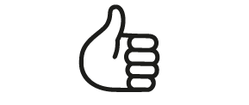 | I want to be involved in the film / photography. | Yes ☐ | No ☐
 | I agree that you can record my voice and my image. | Yes ☐ | No ☐
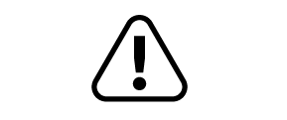 | I understand that I can change my mind about taking part in the film at any time. | Yes ☐ | No ☐
 | I know if I have any concerns that I can talk about it with the team. | Yes ☐ | No ☐
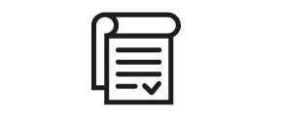 | I agree to take part in the film / photography. | Yes ☐ | No ☐

