

General Consent Form
Permission to use photographs and film footage

Use of photographs and film
These photographs / this film footage will be used solely to promote the activities of Edinburgh Napier University
and our partners in the UK and overseas. Your images or words may appear in any of our promotional materials in
printed or electronic form including web sites, social media, in multimedia productions, course leaflets or prospectus.
Please note that websites can be seen worldwide and not just in the UK where UK law applies.
Use of words and quotes
Quotes and words from my interview will be used solely to promote the activities of Edinburgh Napier University
and our partners in the UK and overseas. Your words may appear in any of our promotional material in printed
or electronic form including web sites, social media, paid/promoted advertising, in multimedia productions,
course leaflets or prospectus. Please note that websites can be seen worldwide and not just in the UK where
UK law applies. Interviews will be edited for concision and clarity.
Data Protection legislation
To comply with Data Protection legislation, we need your permission before we take any photographs or film footage
of you. We normally store photographs securely in our image library for no longer than five years; however, your
photograph or film footage may be selected for inclusion in our historical archive and be retained indefinitely.
Images and film footage in the Historic Archive library will not be used for promotional or marketing purposes.
There may be times during the 5-year period when we contact you to ask you to refresh your consent e.g. if your image is scheduled to appear in a major campaign.
You can contact us using the details at the end of this form to request removal of photos or film at any time, but please note that in certain circumstances we may not be able immediately to erase or delete images or footage already published.
Consent
I consent to the use of my images / words for the purposes and uses outlined above and in accordance with the terms
of current Data Protection Legislation.
I understand that where group photos are to be taken my verbal consent will be sought and recorded.

Name

Contact details
Course

Any other info

For further information please contact: Organiser to add contact details

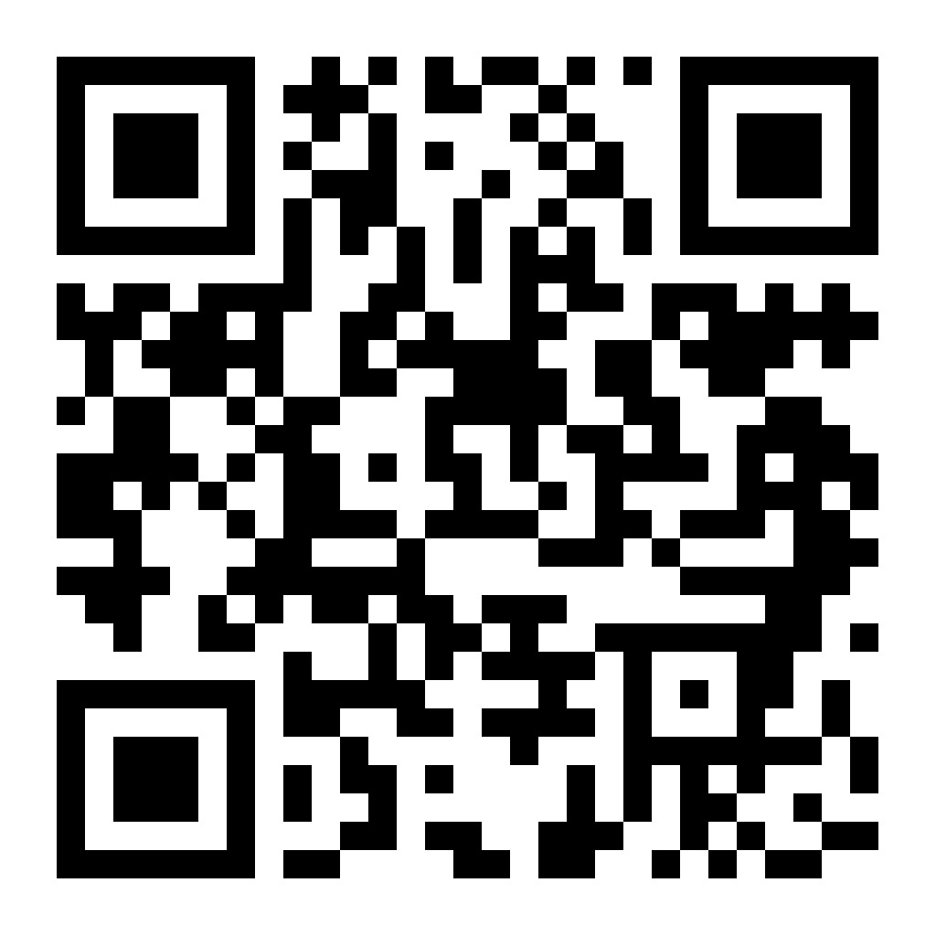

Further information on your rights under DP legislation can be obtained from the University’s Data Protection Code of Practice. https://www.napier.ac.uk/privacy-policy/privacy-notices

